Navigating Google Classroom
Students must first log into to their School Google Account.
- If your student(s) have already logged in they will see the welcome pages; this appears one the first log in only.
- If your student(s) have NOT already logged in, please see the Logging into Google Classroom Tutorial Sheet.
1) Click, ‘Continue’ to Join a class and begin using a Teachers Classroom.
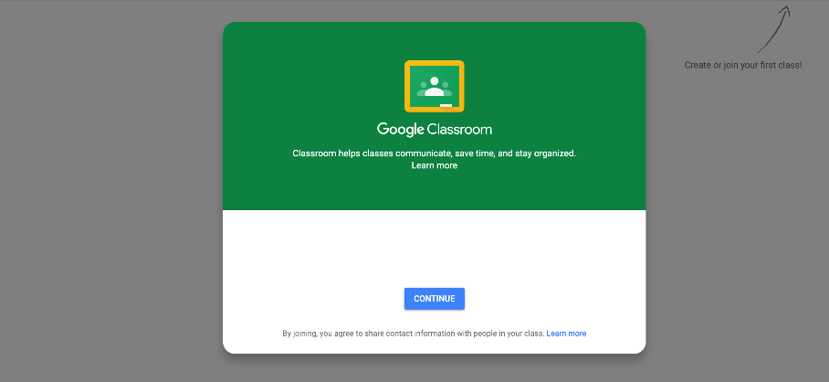
*** NOTE: If your teacher has sent you an email – joining a class may be done through that email. Contact Teacher with any problems. ***

2) Click the + icon in the top right corner of the screen.

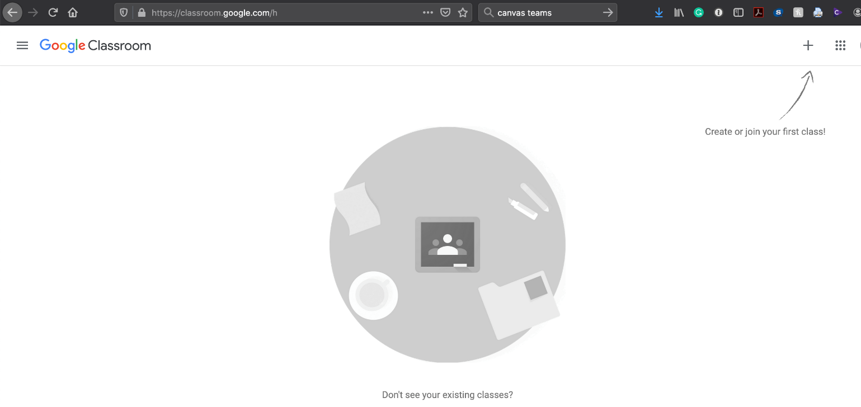

3) When the field expands, click ‘Join Class’. A window will appear in the center of the screen. Students will need the CLASS CODE provided to them by their teacher. After typing in the CODE, click join to add the class and begin viewing materials.

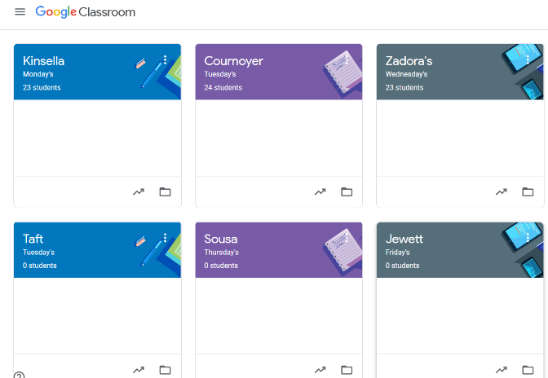
Students can add multiple codes to their account. The different classes will appear in a tiled format on their dashboards.
Example:

